GET DATA
/TYPE=XLS
/FILE='C:\Users\EFILGUER\Downloads\DatingSurveyCatetegorialData.xls'
/SHEET=name 'Dating Survey'
/CELLRANGE=FULL
/READNAMES=ON
/DATATYPEMIN PERCENTAGE=95.0.
EXECUTE.
DATASET NAME DataSet1 WINDOW=FRONT.
NEW FILE.
DATASET NAME DataSet2 WINDOW=FRONT.

GET DATA
/TYPE=XLSX
/FILE='C:\Users\EFILGUER\Downloads\WineConsumption.xlsx'
/SHEET=name 'Sheet1'
/CELLRANGE=FULL
/READNAMES=ON
/DATATYPEMIN PERCENTAGE=95.0
/HIDDEN IGNORE=YES.
EXECUTE.
DATASET NAME DataSet3 WINDOW=FRONT.
DATASET ACTIVATE DataSet1.
DATASET CLOSE DataSet2.
GRAPH
/BAR(GROUPED)=COUNT BY LengthofRelationshipInWeeksrecoded BY RelationalSatisfaction1to7recoded.

Graph

Notes
Output Created |  | 04-FEB-2019 10:51:44
Comments
Input | Active Dataset | DataSet1
Input | Filter | <none>
Input | Weight | <none>
Input | Split File | <none>
Input | N of Rows in Working Data File | 187
Syntax |  | GRAPH  /BAR(GROUPED)=COUNT BY LengthofRelationshipInWeeksrecoded BY RelationalSatisfaction1to7recoded.
Resources | Processor Time | 00:00:00.88
Resources | Elapsed Time | 00:00:00.39

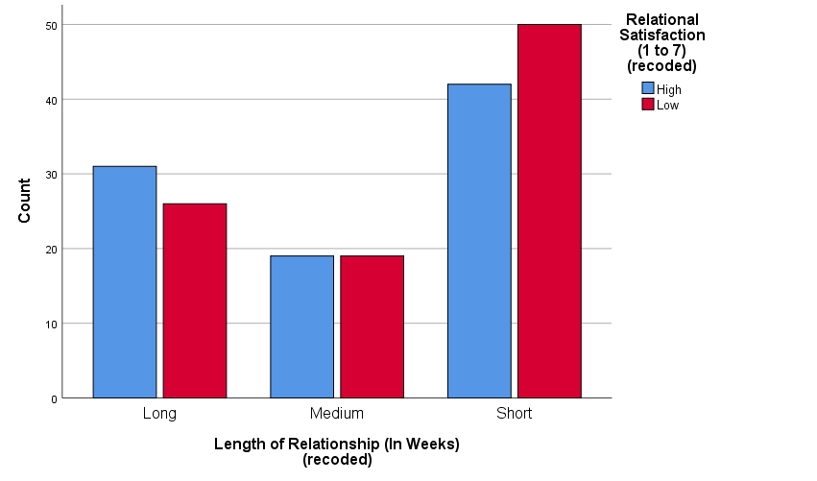

CROSSTABS
/TABLES=LengthofRelationshipInWeeksrecoded BY RelationalSatisfaction1to7recoded
/FORMAT=AVALUE TABLES
/CELLS=COUNT
/COUNT ROUND CELL
/BARCHART.

Crosstabs

Notes
Output Created |  | 04-FEB-2019 10:54:09
Comments
Input | Active Dataset | DataSet1
Input | Filter | <none>
Input | Weight | <none>
Input | Split File | <none>
Input | N of Rows in Working Data File | 187
Missing Value Handling | Definition of Missing | User-defined missing values are treated as missing.
Missing Value Handling | Cases Used | Statistics for each table are based on all the cases with valid data in the specified range(s) for all variables in each table.
Syntax |  | CROSSTABS  /TABLES=LengthofRelationshipInWeeksrecoded BY RelationalSatisfaction1to7recoded  /FORMAT=AVALUE TABLES  /CELLS=COUNT  /COUNT ROUND CELL  /BARCHART.
Resources | Processor Time | 00:00:00.30
Resources | Elapsed Time | 00:00:00.16
Resources | Dimensions Requested | 2
Resources | Cells Available | 524245

Case Processing Summary
 | Cases
 | Valid |  | Missing |  | Total
 | N | Percent | N | Percent | N | Percent
Length of Relationship (In Weeks)  (recoded) * Relational Satisfaction (1 to 7)  (recoded) | 187 | 100.0% | 0 | 0.0% | 187 | 100.0%

Length of Relationship (In Weeks)
(recoded) * Relational Satisfaction (1 to 7)
(recoded) Crosstabulation
Count
 |  | Relational Satisfaction (1 to 7)  (recoded) |  | Total
 |  | High | Low | Total
Length of Relationship (In Weeks)  (recoded) | Long | 31 | 26 | 57
Length of Relationship (In Weeks)  (recoded) | Medium | 19 | 19 | 38
Length of Relationship (In Weeks)  (recoded) | Short | 42 | 50 | 92
Total |  | 92 | 95 | 187

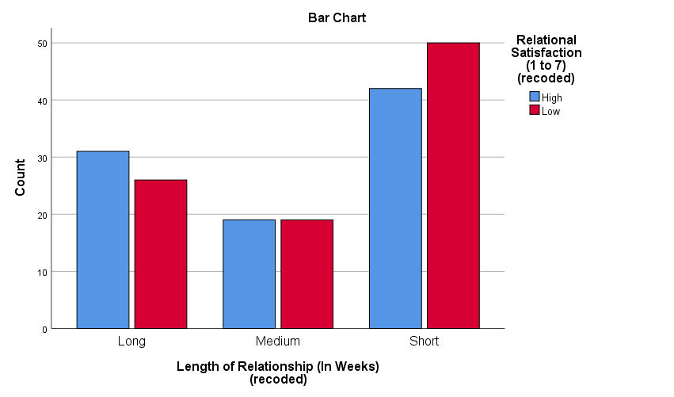

CROSSTABS
/TABLES=LengthofRelationshipInWeeksrecoded BY RelationalSatisfaction1to7recoded
/FORMAT=AVALUE TABLES
/CELLS=COUNT ROW COLUMN TOTAL
/COUNT ROUND CELL
/BARCHART.

Crosstabs

Notes
Output Created |  | 04-FEB-2019 10:58:15
Comments
Input | Active Dataset | DataSet1
Input | Filter | <none>
Input | Weight | <none>
Input | Split File | <none>
Input | N of Rows in Working Data File | 187
Missing Value Handling | Definition of Missing | User-defined missing values are treated as missing.
Missing Value Handling | Cases Used | Statistics for each table are based on all the cases with valid data in the specified range(s) for all variables in each table.
Syntax |  | CROSSTABS  /TABLES=LengthofRelationshipInWeeksrecoded BY RelationalSatisfaction1to7recoded  /FORMAT=AVALUE TABLES  /CELLS=COUNT ROW COLUMN TOTAL  /COUNT ROUND CELL  /BARCHART.
Resources | Processor Time | 00:00:00.20
Resources | Elapsed Time | 00:00:00.13
Resources | Dimensions Requested | 2
Resources | Cells Available | 524245

Case Processing Summary
 | Cases
 | Valid |  | Missing |  | Total
 | N | Percent | N | Percent | N | Percent
Length of Relationship (In Weeks)  (recoded) * Relational Satisfaction (1 to 7)  (recoded) | 187 | 100.0% | 0 | 0.0% | 187 | 100.0%

Length of Relationship (In Weeks)
(recoded) * Relational Satisfaction (1 to 7)
(recoded) Crosstabulation
Relational Satisfaction (1 to 7)
(recoded)
 |  |  | High | Low
Length of Relationship (In Weeks)  (recoded) | Long | Count | 31 | 26
Length of Relationship (In Weeks)  (recoded) | Long | % within Length of Relationship (In Weeks)  (recoded) | 54.4% | 45.6%
Length of Relationship (In Weeks)  (recoded) | Long | % within Relational Satisfaction (1 to 7)  (recoded) | 33.7% | 27.4%
Length of Relationship (In Weeks)  (recoded) | Long | % of Total | 16.6% | 13.9%
Length of Relationship (In Weeks)  (recoded) | Medium | Count | 19 | 19
Length of Relationship (In Weeks)  (recoded) | Medium | % within Length of Relationship (In Weeks)  (recoded) | 50.0% | 50.0%
Length of Relationship (In Weeks)  (recoded) | Medium | % within Relational Satisfaction (1 to 7)  (recoded) | 20.7% | 20.0%
Length of Relationship (In Weeks)  (recoded) | Medium | % of Total | 10.2% | 10.2%
Length of Relationship (In Weeks)  (recoded) | Short | Count | 42 | 50
Length of Relationship (In Weeks)  (recoded) | Short | % within Length of Relationship (In Weeks)  (recoded) | 45.7% | 54.3%
Length of Relationship (In Weeks)  (recoded) | Short | % within Relational Satisfaction (1 to 7)  (recoded) | 45.7% | 52.6%
Length of Relationship (In Weeks)  (recoded) | Short | % of Total | 22.5% | 26.7%
Total |  | Count | 92 | 95
 |  | % within Length of Relationship (In Weeks)  (recoded) | 49.2% | 50.8%
 |  | % within Relational Satisfaction (1 to 7)  (recoded) | 100.0% | 100.0%
 |  | % of Total | 49.2% | 50.8%

Length of Relationship (In Weeks)
(recoded) * Relational Satisfaction (1 to 7)
(recoded) Crosstabulation
 |  |  | Total
Length of Relationship (In Weeks)  (recoded) | Long | Count | 57
Length of Relationship (In Weeks)  (recoded) | Long | % within Length of Relationship (In Weeks)  (recoded) | 100.0%
Length of Relationship (In Weeks)  (recoded) | Long | % within Relational Satisfaction (1 to 7)  (recoded) | 30.5%
Length of Relationship (In Weeks)  (recoded) | Long | % of Total | 30.5%
Length of Relationship (In Weeks)  (recoded) | Medium | Count | 38
Length of Relationship (In Weeks)  (recoded) | Medium | % within Length of Relationship (In Weeks)  (recoded) | 100.0%
Length of Relationship (In Weeks)  (recoded) | Medium | % within Relational Satisfaction (1 to 7)  (recoded) | 20.3%
Length of Relationship (In Weeks)  (recoded) | Medium | % of Total | 20.3%
Length of Relationship (In Weeks)  (recoded) | Short | Count | 92
Length of Relationship (In Weeks)  (recoded) | Short | % within Length of Relationship (In Weeks)  (recoded) | 100.0%
Length of Relationship (In Weeks)  (recoded) | Short | % within Relational Satisfaction (1 to 7)  (recoded) | 49.2%
Length of Relationship (In Weeks)  (recoded) | Short | % of Total | 49.2%
Total |  | Count | 187
 |  | % within Length of Relationship (In Weeks)  (recoded) | 100.0%
 |  | % within Relational Satisfaction (1 to 7)  (recoded) | 100.0%
 |  | % of Total | 100.0%

GRAPH
/BAR(GROUPED)=COUNT BY LengthofRelationshipInWeeksrecoded BY AmountofConflict1to7recoded.

Graph

Notes
Output Created |  | 04-FEB-2019 11:02:38
Comments
Input | Active Dataset | DataSet1
Input | Filter | <none>
Input | Weight | <none>
Input | Split File | <none>
Input | N of Rows in Working Data File | 187
Syntax |  | GRAPH  /BAR(GROUPED)=COUNT BY LengthofRelationshipInWeeksrecoded BY AmountofConflict1to7recoded.
Resources | Processor Time | 00:00:00.17
Resources | Elapsed Time | 00:00:00.14

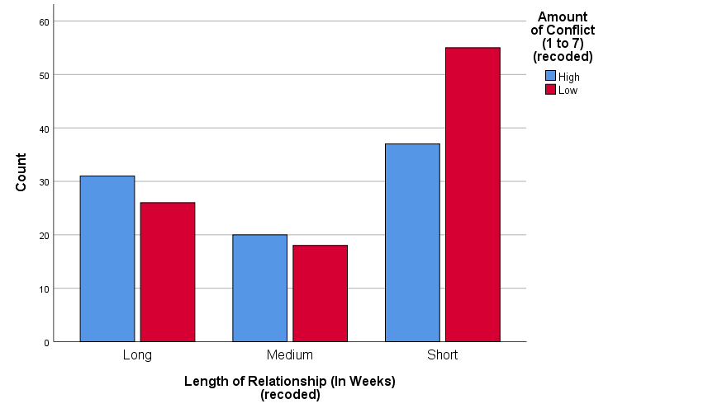

CROSSTABS
/TABLES=LengthofRelationshipInWeeksrecoded BY AmountofConflict1to7recoded
/FORMAT=AVALUE TABLES
/CELLS=COUNT ROW COLUMN TOTAL
/COUNT ROUND CELL
/BARCHART.

Crosstabs

Notes
Output Created |  | 04-FEB-2019 11:03:01
Comments
Input | Active Dataset | DataSet1
Input | Filter | <none>
Input | Weight | <none>
Input | Split File | <none>
Input | N of Rows in Working Data File | 187
Missing Value Handling | Definition of Missing | User-defined missing values are treated as missing.
Missing Value Handling | Cases Used | Statistics for each table are based on all the cases with valid data in the specified range(s) for all variables in each table.
Syntax |  | CROSSTABS  /TABLES=LengthofRelationshipInWeeksrecoded BY AmountofConflict1to7recoded  /FORMAT=AVALUE TABLES  /CELLS=COUNT ROW COLUMN TOTAL  /COUNT ROUND CELL  /BARCHART.
Resources | Processor Time | 00:00:00.17
Resources | Elapsed Time | 00:00:00.14
Resources | Dimensions Requested | 2
Resources | Cells Available | 524245

Case Processing Summary
 | Cases
 | Valid |  | Missing |  | Total
 | N | Percent | N | Percent | N | Percent
Length of Relationship (In Weeks)  (recoded) * Amount of Conflict (1 to 7)  (recoded) | 187 | 100.0% | 0 | 0.0% | 187 | 100.0%

Length of Relationship (In Weeks)
(recoded) * Amount of Conflict (1 to 7)
(recoded) Crosstabulation
 |  |  | Amount of Conflict (1 to 7)  (recoded) |  | Total
 |  |  | High | Low | Total
Length of Relationship (In Weeks)  (recoded) | Long | Count | 31 | 26 | 57
Length of Relationship (In Weeks)  (recoded) | Long | % within Length of Relationship (In Weeks)  (recoded) | 54.4% | 45.6% | 100.0%
Length of Relationship (In Weeks)  (recoded) | Long | % within Amount of Conflict (1 to 7)  (recoded) | 35.2% | 26.3% | 30.5%
Length of Relationship (In Weeks)  (recoded) | Long | % of Total | 16.6% | 13.9% | 30.5%
Length of Relationship (In Weeks)  (recoded) | Medium | Count | 20 | 18 | 38
Length of Relationship (In Weeks)  (recoded) | Medium | % within Length of Relationship (In Weeks)  (recoded) | 52.6% | 47.4% | 100.0%
Length of Relationship (In Weeks)  (recoded) | Medium | % within Amount of Conflict (1 to 7)  (recoded) | 22.7% | 18.2% | 20.3%
Length of Relationship (In Weeks)  (recoded) | Medium | % of Total | 10.7% | 9.6% | 20.3%
Length of Relationship (In Weeks)  (recoded) | Short | Count | 37 | 55 | 92
Length of Relationship (In Weeks)  (recoded) | Short | % within Length of Relationship (In Weeks)  (recoded) | 40.2% | 59.8% | 100.0%
Length of Relationship (In Weeks)  (recoded) | Short | % within Amount of Conflict (1 to 7)  (recoded) | 42.0% | 55.6% | 49.2%
Length of Relationship (In Weeks)  (recoded) | Short | % of Total | 19.8% | 29.4% | 49.2%
Total |  | Count | 88 | 99 | 187
 |  | % within Length of Relationship (In Weeks)  (recoded) | 47.1% | 52.9% | 100.0%
 |  | % within Amount of Conflict (1 to 7)  (recoded) | 100.0% | 100.0% | 100.0%
 |  | % of Total | 47.1% | 52.9% | 100.0%

